Joseph Ayo

Module 6.2 Assignment – CSD 310

11/24/24

1. Sourcing SQL file

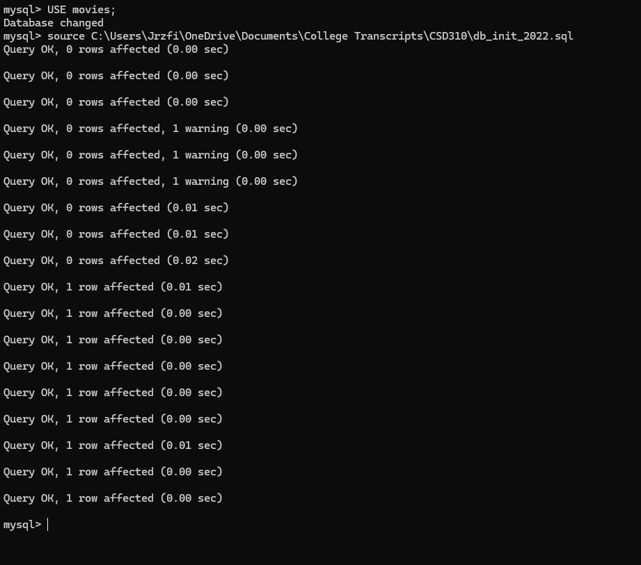

1. Show TABLES in movies

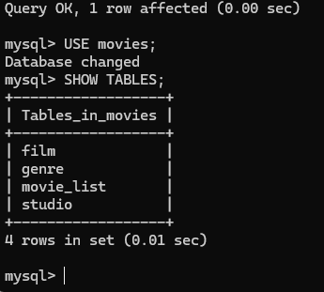

1. Run mysql_test.py

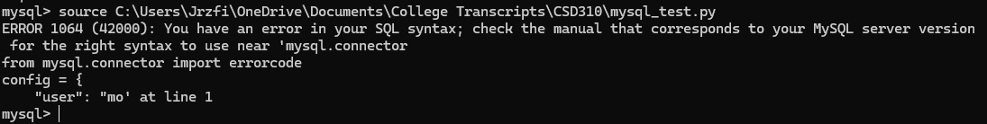

IMPORTANT:  
No matter what I tried, I was unable to resolve this syntax error when trying to use the SOURCE command to import the contents of the test file. Here is a list of some things I tried to resolve this error:  
1. Ensuring that mysql-connector 2.2.9 was properly installed using the command ‘pip install mysql-connector' in a command prompt (NOT the SQL command line). I verified that it was installed by using the command ‘pip show mysql-connector':

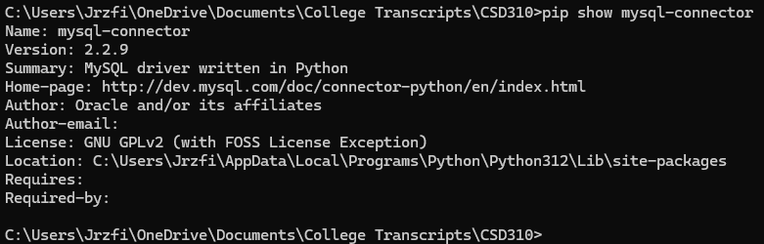2. Installing ’pip3 install mysql-connector-python', which works with newer versions of Python to achieve the same purpose. Also verified using ’pip show’:

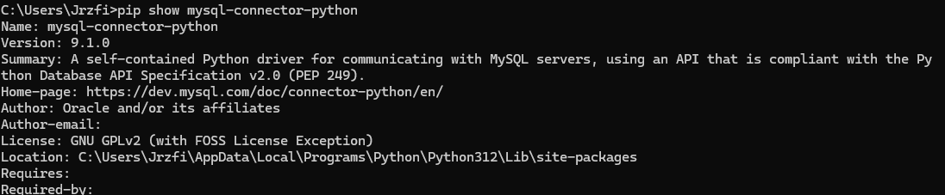3. Rewriting the entire .py file in a Python editor, Visual Studio Code. My first draft was written in Notepad as a .py file, as the instructions suggested. I checked numerous times for any incorrect formatting of the given lines of code:  
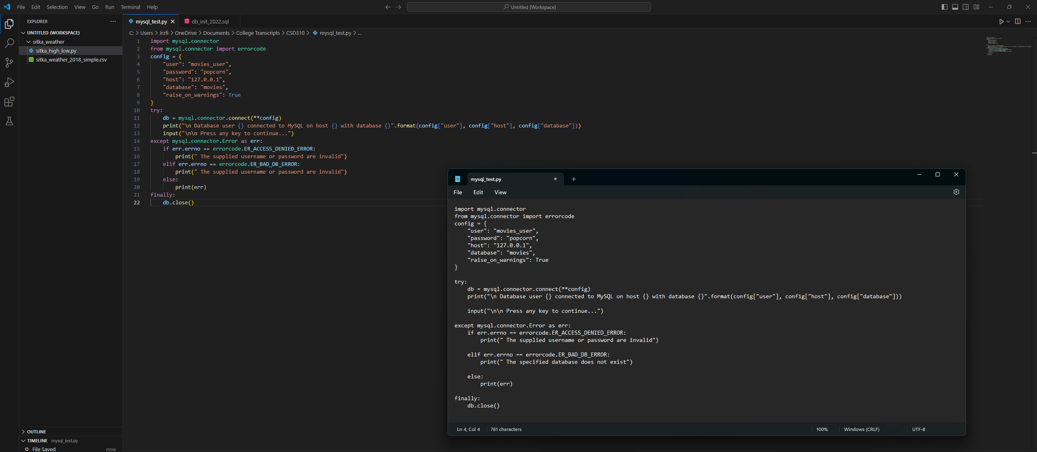4. Scouring the internet for common solutions. Based on my research I assume the issue lies with MySQL not recognizing Python syntax, which is supposed to be remedied by mysql-connector, but is not being recognized for one reason or another. I‘m confident that my code would work if only I could get MySQL to recognize the Python syntax. I used the db_init_2022.sql file and it worked flawlessly, so my username should be ’movies_user’ and my password should be ’popcorn’.  
  
I spent a long time on this and understand that I can’t get full credit for an incomplete assignment, but I do not know how to fix this issue. Any advice?